Theory Overview
There's way too much to digest all at one time. BUT if you read it all once, to get the gist of what I'm talking about, then study it over and over, by topic, you'll get a TON out of it! Plus, you'll know more music theory than about 80% of the jammers in the world. ☺
Before you read this, let me preface it as follows . . .
`
We all wanna be the best we can. No doubt. And we wanna learn all we can. And I encourage that, too. To a point! HOWEVER . . . that being said . . . How about just playin' the darned thing. Having some fun. Let's make this simple.
OK, I'm gonna put this into a simple format. My focus is on simplicity, not perfection. So all you experienced players, don't go hammering me about some minor point that makes this more complicated than it really is. Fair enough? For the most part, I kept this in simple form, focusing on using player’s terms. This isn’t a theory book. It’s just a guide.
Have some fun with this? If you follow this, and commit just a little bit to memory, I think you'll start playing, and enjoy playing a lot more. (For now! But you still need to learn all you can as you progress!)
The Chromatic scale This is nothing more than all 12 of the keys on a keyboard. And they're in alphabetical order. So how hard can it be? You have just A , B, C, D, E, F & G. Most of them have a sharp (#) or flat (b) associated with them.
Sharp (#) just means one half step (one key on the piano – one fret on a guitar) higher than the "name" of the note. A# is one key higher than A. (And on keyboards, it'll be a black key.)
Flat (b) just means one half step (one key on the piano – one fret on a guitar) lower than the "name" of the note. Bb is one key lower than B. (And on keyboards, it'll also be a black key. In fact, it’s the same key as the A#.)

SIDEBAR: OK, you pros, don't go interjecting advanced theory, Medieval theory or OLD keyboard structure on this next part. As I said, I'm trying to make this simple to understand. END SIDEBAR
Some notes share a name. An A# is the same note as a Bb. Look at a keyboard. The black key between A and B is named, based on the relationship to the key it's in. It's one key higher than an A. So you could call it an A#. It's also one key lower than a B. So you could also call it a Bb. Same note. Same sound. (CALLED ENHARMONIC)

So, if you were to name all of the notes, starting with C, you'd have: C C#/Db D D#/Eb E F F#/Gb G G#/Ab A A#/Bb B
Natural keys C D E G A B Flat keys Db Eb F Gb Ab Bb Natural keys have sharps. The keys are: C Db D Eb E F Gb G Ab A Bb B Look at a keyboard. You'll see 2 places where there is no black key between white keys. . . .
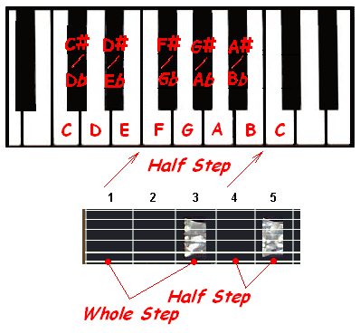
THERE IS ONLY A HALF STEP BETWEEN B & C . . . AND E & F ! ! ! COMMIT THIS TO MEMORY!
So, step one of your memorization . . . learn to "say" the chromatic scale, for natural and flat keys. And remember where the 2 half steps are. (Between B & C, and E & F) Learn to “say” . . .

C C# D D# EF F# G G# A A# BC . . . and . . . C Db D Eb EF Gb G Ab A Bb BC

SIDEBAR: Just so I don't get hammered, here are a few exceptions. The Key of C has no sharps or flats. And you will (from time to time) see chord charts for a tune in the key of F# instead of Gb. But that's because no one's perfect! ☺
Um, you might actually see chord charts for other "sharp keys". Just consider the source, and know the difference. As long as you know that an Eb is also a D#, you're fine.
Chords. Where the heck do the chords come from in the first place? Everything comes from the Major Scale! And it’s easy to
figure out just about any chord. You pretty much just pick a start point, then skip over every other note. EZ! Kinda Sorta!

Start on the C major scale: (Do Re Me Fa So La Ti Do) Go every other note and you get . . . C E G C major chord. On guitar or Uke,
you change all of the strings so they play one of those 3 notes: C E G. C, E and G are the 1st, 3rd and 5th notes of the C Major scale.

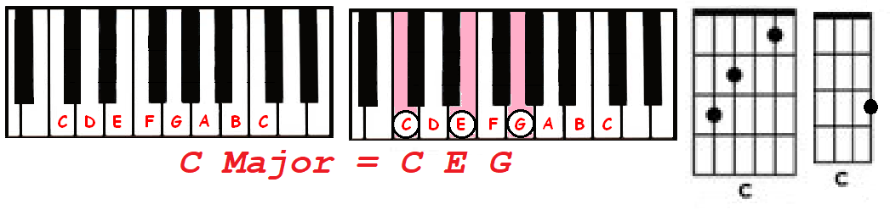

Skip over one more and then the next note is B. That’s a Cmaj7. Skip and add again, you get a D, the 9th note of the C scale. Also
the 2nd an octave below. (As in sus2 chords, play the 2nd instead of the 3rd)

Again, you get F, the 11th Also the 4th in the octave lower. (As in sus4 chords, play the 4th instead of the 3rd.) Go again and get A,
the 13th (or 6th an octave below, Add6 chords)

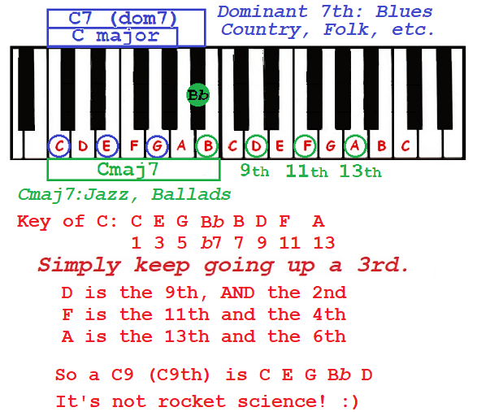

You literally went every other note in the scale, moving up in 3rds. Called stacking 3rds. And you got all
of the chord extensions there are. There are more variations to chords. I just wanted you to see how we
get the notes. Pretty easy.

Let’s take a short look at the “music”. A real music staff and what the notes, and chords look like.
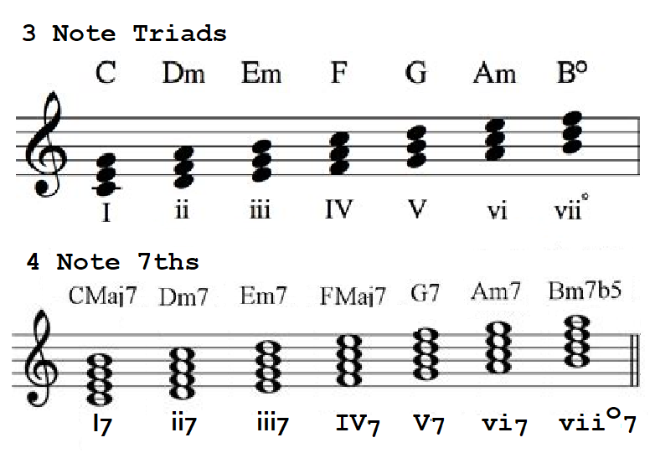

Remember the ol' Do Re Me thang you learned in elementary school? We can all recognize a major scale when we hear one.
All ya gotta know is . . . where the half steps in a scale belong. Then use the Chromatic scale, and plug notes in. Like this . . .

The Chromatic Scale is just ALL of the notes. And you’ll see below some keys have sharps (#) and some have flats (b).
So we can start at any note, any key. But I’ll start from C here . . . C Db D Eb E F Gb G Ab A Bb B C And using sharps
(to get the same identical notes!) C C# D D# E F F# G G# A A# B C

On a keyboard, the black notes are the sharps, or flats. Depends on the key. NOTE: Contrary to what many people might tell
you . . . it is NOT true, that how you know when to call a note a sharp or flat depends on what direction you’re moving along
the keyboard! As in . . . You do NOT necessarily call one black note a flat because you’re playing a melody from right to left, going DOWN the keyboard. Sorry, but that’s just dumb! And therefore you should call a note a sharp if you’re going left to right up the keyboard? WRONG! Or if a guitarist is playing a melody moving up the scale, then the “off notes” are all sharps? NOPE! He’s
playing a solo moving down the fretboard. So are the notes flats? NO! Well, they COULD be. But not because of the direction
you’re moving/playing. There is ONE thing that determines whether you call a note a flat or a sharp. And that ONE THING is . . .

The KEY you’re in!

C major has no #s or bs, right? So the notes will be . . . . C D EF G A BC . . . Note that there is a half step between the 3rd and 4th
notes of the major scale. And also between the 7th and 8th.
To make a G scale . . . do the same thing. Start by typing out all the notes, starting from G. Then you want the spaces between them
to be (Whole Step (W) Half step (H)) . . . W WH W W WH Say out loud: whole whole half…whole whole whole half many times!

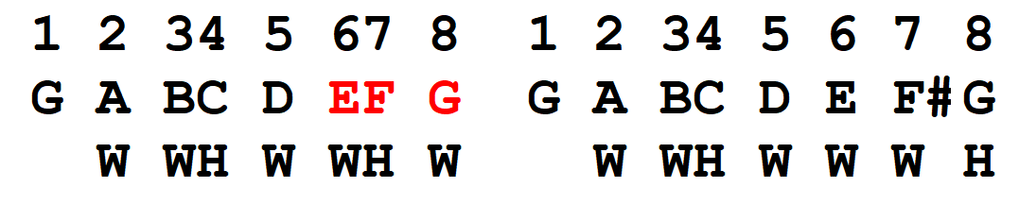
Now, look at notes 3 and 4. You need a half step in there. 3 is B. 4 is C. Perfect! Now look at 7 and 8. Hmmmm. There's a whole step! Yikes!!!! And look at 6 & 7 while you're at it. OUCH! Only a half step! No problem.
Change the F to F# . . . Now there's a whole step between 6 & 7 and a half step between 7 & 8 as there should be. It's really that simple. G A BC D E F#G Look at your Circle of 5ths. How many sharps are in the key of G? 1! We’ll study the Circle of 5ths later.
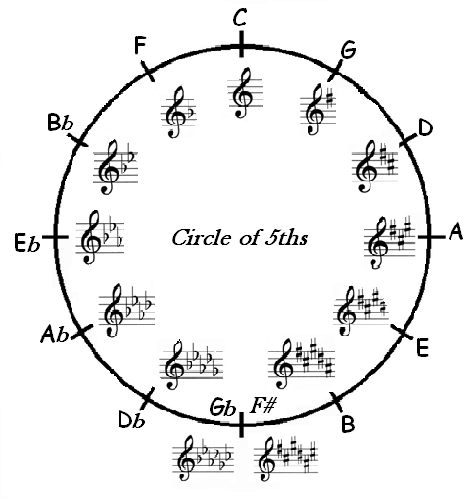
Note that the key of G has 1 sharp, NOT one flat! Here's why. You could have just as easily made the F a Gb. You would still have a half step between 7 & 8, right? But could you have both a G and a Gb in the same scale? Simply put, you can't! So you make it an F#. Same for all the other "Natural" keys. So natural keys will have sharps. The other keys are flat keys!
OK you pros. Argue this point if ya like. But then try to explain to someone how the key of E could have flats in it! Let's see . . . .
E F G A B C D E . . . half steps need to be between 3&4 and 7&8. So let's make them right, using flats . . . E Gb Ab A B Db Eb E

Can you imagine reading the music for a tune in the key of E, written in flats! How hard would that be? A note on one space could be an A or an Ab. And a note on another space could be an E or an Eb.
Now let's rewrite the E scale using sharps . . . E F# G# A B C# D# E Somehow that makes a lot more sense to me. Here are 2 of the “no exception” RULES in music . . .

1). In a major scale you must have 1 of EACH note represented. So there must be an A, B, C, D, E, F & G in the scale.
2). You cannot have more than one instance of ANY note. As in, you cannot have an F and an F# in the scale.

And that’s how easy it is. Literally pick the key. Start with the note of the key you picked. EX: A Write every note, because you need
1 of each . . . A B C D E F G A Apply W WH W W WH . . . A to B, OK. B to C, NOPE. You need a whole step. So change C to C#. C# to D is OK. D to E is OK. E to F, NOPE. Make it F#. F# to G, NOPE. Make it G#. G# to A, OK. So A B C# D E F# G# A. Look at the Circle of 5ths. How many sharps does the key of A have? 3!

Here’s how we used to do it … I get a call from the Union Hall. “Hey, Wayne. You’re playing at the VFW on 5th Street, Friday, 8 pm.
Look for Bob. Keys. He’s the lead man.” Friday, 7:40pm I look for Bob. I say “Hey, Bob. I’m Wayne, guitar” He nods and points to
the right. I set up on the right side of the drummer. No sound check! I’m expected to view the place and figure our my volume.
Start a bit low then bring it up. 8PM SHARP Bob holds his hand up and points up with 3 fingers and starts playing. No count in.
No hints except 3 fingers pointing up. And somehow, miraculously, we all jump in, and it all works! Then as he finishes up the
last couple notes he raises his hand again and points down with 2 fingers, then starts playing the next song.

HUH! Yeah. 3 fingers UP means 3 sharps. Key of A. Next song, 2 fingers DOWN, 2 flats, Bb. And that’s how it was done. At
least for smaller combos. Not for large orchestras. About the only time he’d refer to anyone in the band would be when
he’d nod at you to take a solo. No rehearsals. Just show up and 3, 4, sometimes 5 guys would show up, never played
together before. And we’d do a whole 4 hour show! If you had a fake book, you’d flip to the song as you played the
beginning, if you didn’t know it. Assuming you knew the name of the song he was playing.
Chords . . .
There are 4 "flavors" of a chord. Major, minor, diminished and augmented. Just memorize these 4 easy formulae . . .
Major: 1st, 3rd & 5th notes of the scale. Key of C: C D E F G A B C So a C Major Chord would be these 3 notes: C E G
Memorize: Major = 1, 3 & 5 Maj, M or a small triangle (indicating a triad), or nothing. C by itself would be C major.
As would CMaj, Cmaj or CM.
Minor: 1st, b3rd, 5th notes of the scale. Only difference between a C Major and a C minor chord is, you flat the 3rd
note. (b3rd) Pronounced “flatted third”. So a C minor would be: C Eb G
Memorize: Minor = 1, b3 & 5 min or m . . . Cmin or Cm . . . or – (minus sigh) C-
Diminished: 1st, b3rd, b5th Flat the 5th, too, and you have a dim chord. Cdim would be C Eb Gb
Memorize: Diminished = 1, b3 & b5 Dim, - (minus sign) . . . CDim, Cdim or Cº
Augmented: 1st, 3rd, #5th notes of the scale. Caug would be C E G# #5 is a “raised 5^{th”} or “sharp 5”, or “sharped 5^{th”}.
Memorize: Augmented = 1, 3 & #5 Aug, (plus sign) + . . . CAug, Caug or C+
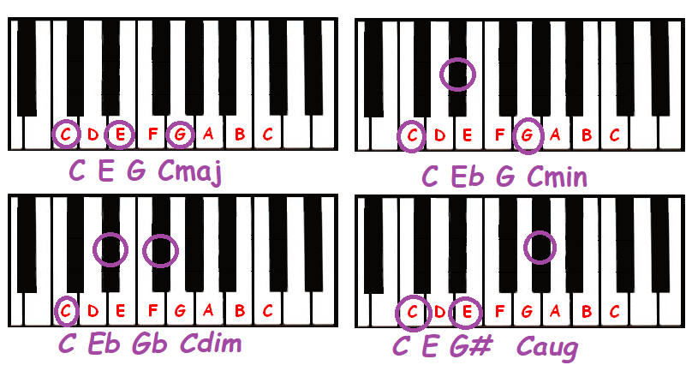
Chord Scales . . .
Basically, a chord scale is a major scale, played in chords. These will be the most common chords in that key. If you were to sing or hum a major scale in "C", you'd sing . . . C D E F G A B C
But if you were to play those same notes as major chords, as in . . . Cmaj, Dmaj, Emaj, etc . . . and sing the scale over the chords, it wouldn't sound right at all. Some would sound OK. Some, not so good.
If you were to play . . . Cmaj, Dmin, Emin, Fmaj, G7th, Amin, Bdim, Cmaj . . . it would sound perfect! So if you’re trying to figure
out the chords for a song, they will most likely be some of the 7 chords in the chord scale of that key!
C Major’s chord scale (triad, 3 notes) is . . . C Dm Em F G Am Bdim C
C Major’s Jazz chord scale (7ths, 4 notes) is . . . Cmaj7 Dm7 Em7 Fmaj7 G7 Am7 Bm7b5 C

Here's how to write a C major chord scale. Write out the notes of the scale. C D E F G A B C You’re going to go to each note
in the scale and make it into a 3 note chord. Going 1st, 3rd, 5th starting with each chord. LATER . . . you can do the same thing,
but go one step further and make a chord scale using FOUR notes instead of three. This will be the Jazz Chord Scale with 7ths.

NOTE: As you go from note to note making new chords, you know what the chord flavor is by comparing the 3 notes you get
making the new chord to the scale of the new chord you’re making. EX: C = 1st, 3rd and 5th note. Go to the D and go up to the 3rd
and 5th above D. D F A. Look at a D Major scale. Compare the D Major scale to the 3 notes in the D chord you just made. You’ll
see the D Major scale is D E F# G A B C# D. The new chord you just made is D F A. So you have a b3, right? So the D is a Dm.
Chord 1 is the 1st, 3rd and 5th notes of the scale. C E G is a C major.
Chord 2 is the 1st, 3rd and 5th notes of that scale, STARTING FROM NOTE 2! D F A, which is a Dmin. The F# in a D scale is flatted to F here. b3 is minor. Also, the 2nd note in the scale is referred to as the “2nd Degree” of the scale. 3rd note is 3rd Degree, and so on.

Chord 3 is the 1st, 3rd and 5th notes of that scale, STARTING FROM NOTE 3! E G B, which is an Emin. The G# in an E scale is flatted to G here. b3 is minor.

Chord 4 is the 1st, 3rd and 5th notes of the scale starting from note 4! F A C Fmaj

Chord 5 is the 1st, 3rd and 5th notes of the scale starting from note 5! G B D
USUALLY PLAYED AS A DOM7 CHORD, adding a b7(F) note. G7 = G B D & F 1 3 5 b7
Chord 6 is the 1st, 3rd and 5th notes of that scale, starting from note 6! A C E, which is an Amin. The C# in an A scale is flatted to C here. b3 is minor.
Chord 7 is the 1st, 3rd and 5th notes of that scale, starting from note 7! B D F, which is a Bdim. The D# & F# in a B scale are flatted to D & F here. b3 & b5 is dim.
If you just wrote out a C scale, then under it, wrote the same scale, starting on the 2nd note, then under that, starting on the 3rd, etc . . . you'd have the C major scale 7 times, just starting on a different note of the same scale. Simple enough. Then go 1 3 5 on each, and you have the notes for that chord of the chord scale. AND . . . you also have listed all of the Modes of the key of C!
C D E F G A B C (Ionian Mode)
D E F G A B C D (Dorian Mode)
E F G A B C D E (Phrygian Mode)
F G A B C D E F (Lydian Mode)
G A B C D E F G (Mixolydian Mode)
A B C D E F G A (Aeolian Mode) - THIS IS ALSO AN A MINOR SCALE. Note the half steps between 2&3 & 5&6.
B C D E F G A B (Locrian Mode)

I'm not going there now, but if you re-read all the great posts about modes . . . I think you'll better understand them now.
I will make one point now about modes. Many associate a modal scale with its root key. This is incorrect! In the above example, the 2nd scale is Dorian mode of the D scale. You would use this scale to play in the key of D, not C. Ideally, you’d use it over a
D Dorian chord progression.

We won’t go into Modes much in this tutorial. But just to get you started, here are a handful of Dorian chord progressions you can
play over using the Dorian Mode. You can think of it like just playing a C major scale over the progression, but start playing, starting on the D note, and emphasize the D, NOT the C throughout your playing. That’s not really the best way to describe it. But it IS the
easiest to understand for now, until we delve a little deeper into Modes a bit later.

1). Dm C F G % 2). Dm F G G %
i VII III IV i III IV IV

3). Dm Em F Em % 4). Dm Am G Dm %
i ii III ii i v IV i

5). Dm C Bb G % 6). Dm F G Bb %
i VII bVI IV i III IV bVI

Using the Chord Scale (Also called the Jazz Harmony Scale)

A Blues progression is often called a I IV V (1 4 5) In C, look at the scale. That would be C F & G7. When you hear a musician say "It's a 2-5 in C", he means you're playing a Dm & G (or G7).
And a I V IV (1 5 4) is C G7 F. A I vi ii V (1 6 2 5) is C Am Dm G7 , Etc.
Examples: A ton of "American" music is written in 12 bars. Meaning the pattern of chords to get through a verse takes 12 bars, or measures.
Johnny B. Goode is a 1 4 5 Rock n Roll tune. In "C", the chords for the 12 bars (one verse) would be . . .
[:|1|2|3|4 |5|6 |7|8 |9 |10|11|12 |:]
[:|C|%|%|C7|F|F7|C|C7|G7|% |C |C ' ' '|:]
“ % ” means repeat previous measure or bar. “ :] “ means go back to the “ [: “ and repeat from there.
A lot of old swing tunes are 12 bar 1 4 5 progressions. With some extra chords in the mix for flavor, sometimes. And sometimes "sweeter" chords are substituted to replace some chords that are repeated often. Like measures that use one chord for a whole 4 count measure.
In a slow Blues tune, it can get boring listening to a C chord for 4 whole measures. So sometimes we'll play something like this . . .
In the above progression in C, instead of playing 2 more whole measures of a C major chord for measures 7 & 8, I might "substitute" this . . .
|1 2 3 4 | 1 2 3 4 | |1 2 1 2| 1 2 1 2|
|C ' ' ' | C ' ' ' | could become . . . |C ' Dm '| Em ' Eb7 '|
Not so boring. The neat thing is . . . you can play right over the C Dm Em and Eb7 just like it was a C for all 8 counts!
Johnny B. Good in C would be . . .
C ' ' ' C ' C7 '
Way Down In Louisiana, down in New Orleans . . . Way back among the trees back by the Evergreens . . .
F ' F7 ‘ C ' C7 ‘
There stands a log cabin made of earth and wood . . . And lives a country boy named Johnny B. Goode . . .
G7 ' ' ' C ' ' '
He never ever learned to read or write so well, but he could play a guitar just like ringin' a bell . . .
A basic Blues progression is the same thing. TONS of Country tunes are also 1 4 5 progressions. 1000's of tunes are either 1 4 5's or slight variations of a 1 4 5. Like a 1 5 4. Bring It On Home To Me, for instance, is a 1 5 4.
Your Cheating Heart. Yep, 1 4 5. Cold, Cold Heart. Big Boss Man. Detroit City (I Wanna Go Home). Kansas City. The Green Green Grass Of Home. All 1 4 5's!
A 1 6 4 5 would be like "Where Have All The Flowers Gone." C Am F G
A 1 6 2 4 would be similar. "This Boy" by the Beatles comes to mind. C Am Dm G (The actual recording is in D . . . D Bm Em A) Remember “Then You Can Tell Me Good-Bye” by The Casinos? Same progression.
All the chords are in the C major chord scale, right? C Am F G And all the notes of all the chords are in a C major scale!
So now, when you pick up a song book that has the guitar chords in it, you'll know where the chords came from.
OK, one more thing that will help you understand where the circle of 5ths comes from. Watch how Major scales "overlap" from the 5th note of each MAJOR scale, starting with the key of C. I SHOW THE SCALES 2 TIMES for illustration purposes.)
1 2 3 4 5 6 7 8
C MAJ: C D E F G A B C D E F G A B C
G MAJ: G A B C D E F# G A B C D E F# G
D MAJ: D E F# G A B C# D E F# G A B C# D
A MAJ: A B C# D E F# G# A . . .
And so on.
Note that the 1st 4 notes of the forward 5th scale are the same as the last four of the preceding scale. And only 1 (the 3rd) note of the 2nd 4 is different from the last 4 of the preceding scale. C D E F G A B C is C major The 1st 4 notes of the G major are the same as C major's last notes. G A B C.

And the last 4 notes of the G scale are the same as the C scale, except for the 3rd note. And that note is raised. (F becomes F#, etc.)
I hope this will make sense as you read it over and over. : )
Putting some basic theory to work . . .
OK, let’s build some chords, chord phrases and chord progressions. We’ll start with a simple progression, then beef it up some. I discussed some progression basics above. So, because so much of American music is built around 12 bars, and I IV V progressions, we’ll start there.
Let’s take a really simple, straight Blues progression in G. This could just as easily be used as a Country, Folk or Rock progression.
A [:| G ‘ ‘ ‘ | % | % | % | C ‘ ‘ ‘ | % | G ‘ ‘ ‘ | % | D ‘ ‘ ‘ | C ‘ ‘ ‘ | G ‘ ‘ ‘ | D ‘ ‘ ‘ |:]
If our band played this exact progression, we’d need to add a lot of vocal and instrumental dynamics, or it could end up getting boring for our audience really quickly! It starts with 4 measures of G. Then 2 measures of C. Then back to G again for 2 more measures. (bars) This kind of simplicity will be boring unless the instrumentalists add some dynamic strumming and solos. The vocals will also need to be pretty dynamic. So let’s make the progression more interesting.
B [:| G ‘ ‘ ‘ | % | % | G7 ‘ ‘ ‘ | C ‘ ‘ ‘ | C7 ‘ ‘ ‘ | G ‘ ‘ ‘ | G7 ‘ ‘ ‘ | D7 ‘ ‘ ‘ | C7 ‘ ‘ ‘ | G ‘ ‘ ‘ | G ‘ D7 ‘ |:] Note bar 12 is split.
OK, that’s a bit better. Let’s go a little further. A common modification of a basic progression is called a “quick change”. We’ll replace those first 4 boring measures with a quick change. We replace the second bar of the I with the IV.
C [:| G ‘ ‘ ‘ | C ‘ ‘ ‘ | G ‘ ‘ ‘ | G7 ‘ ‘ ‘ | C ‘ ‘ ‘ | C7 ‘ ‘ ‘ | G ‘ ‘ ‘ | G7 ‘ ‘ ‘ | D7 ‘ ‘ ‘ | C7 ‘ ‘ ‘ | G ‘ ‘ ‘ | G ‘ D7 ‘ |:]
We can also raise the I chord a half step in the 3rd bar and split the 4th bar like we did in the 12th bar above.

D [:| G ‘ ‘ ‘ | C ‘ ‘ ‘ | G ‘ Ab ‘ | G ‘ G7 ‘ | C ‘ ‘ ‘ | C7 ‘ ‘ ‘ | G ‘ ‘ ‘ | G7 ‘ ‘ ‘ | D7 ‘ ‘ ‘ | C7 ‘ ‘ ‘ | G ‘ ‘ ‘ | G ‘ D7 ‘ |:]

When I use this change, I like to change the 4th bar as well. From | G7 ‘ ‘ ‘ | to | G ‘ G7 ‘ |. Here’s why.

Note in the upper progression (D), the phrasing of the bars is changing. Initially (A) we had 4 bars that all sounded the same. All G. I’ll use da’s and de’s to show changes in sound. Called cadence. Cadence is a melodic configuration or series of chords marking the end of a phrase. I’m only going to reference the first 4 bars below. But note that we made a few changes in the other measures as well, adding a 7th. But this also helps add cadence to the rest of the progression.

4 bars of G have no changes in sound, or cadence. | da da da da | da da da da | da da da da | da da da da |
Then, in progression (B) we made a couple changes. The first 4 measures changed slightly. We added a G7.
| da da da da | da da da da | da da da da | de de de de |
The quick change in progression (C) broke up the 2nd bar. So bar 2 and 4 changed a bit.
| da da da da | de de de de | da da da da | de de de de |
When I added the Ab in bar 3, we added another sound change. But this time it’s within a bar.
da da da da | de de de de | da da de de | da da da da | So bar 3 has two sounds. Bar 4 is OK the way it is. But I like changing bar 4 as well, so it also has 2 sounds. The first 4 bars will “break up” into 2 bars of 1 sounds each, and 2 bars of 2 sounds each.
| da da da da | de de de de | da da de de | da da de de | Here’s how to get that 2nd sound in bar 4.
E [:| G ‘ ‘ ‘ | C ‘ ‘ ‘ | G ‘ Ab ‘ | G ‘ G7 ‘ | C ‘ ‘ ‘ | C7 ‘ ‘ ‘ | G ‘ ‘ ‘ | G7 ‘ ‘ ‘ | D7 ‘ ‘ ‘ | C7 ‘ ‘ ‘ | G ‘ ‘ ‘ | G ‘ D7 ‘ |:]
Now bar 4 has 2 sounds. The 1st 4 bars are now | da da da da | de de de de | da da de de | da da de de |
Not too bad now. Much more interesting. We can go a little further using the same techniques for measures 5 & 6, and 7 & 8. And there are many interesting possibilities for measures 9 thru 12, commonly called the “turn around”.
Remember the discussion about chord scales? Just like notes can form a melody, so can chords. Let’s try substituting some chords with chord phrases. Don’t forget, the notes of all the chords in the chord scale are all in the major scale. (More about the Eb later.)
F [:| G ‘ ‘ ‘ | C ‘ ‘ ‘ | G ‘ Ab ‘ | G ‘ G7 ‘ | C ‘ ‘ ‘ | C7 ‘ ‘ ‘ | G ‘ Am ‘ | Bm ‘ Bb7 ‘ | Am ‘ ‘ ‘ | Eb ‘ D7 ‘ | G ‘ C7 ‘ | G ‘ D7 ‘ |
OK, this is a much more interesting progression! But can we go further without over-doing it? Sure. Imagination is the only limitation. We’ve created a more jazzy sounding progression. So let’s take that idea, going “jazzy”, a step further. Just a little bit.
Just as you can make those major chords 7ths, so can you make minor chords (or diminished and augmented) 7ths.
And 9ths sound great in Blues and jazz. A 9th is a Dom7th, and a 9th.

NOTE: If you want a Dom9th chord you also need a b7. Same with an 11th. You need a b7, the 9th and the 11th. And ditto for a 13th.
You need a b7, the 9th and the 11th with the 13th. That’s what keeps it Dominant. Otherwise they are just “added” 9ths, etc.
Example: C D E F G A Bb C D E F G A Dom 7th = flat the 7th. B becomes Bb. The 9th is D. C9 = C E G Bb D
1 2 3 4 5 6 7 8 9 11 13
Now let’s sweeten this progression just a little more.
[:| G ‘ ‘ ‘ | C9 ‘ ‘ ‘ | G ‘Ab7 ‘ | G ‘ G7 ‘ | C ‘ ‘ ‘ | C9 ‘ ’ ’| G ‘ Am7 ‘ | Bm7 ‘ Bb7 ‘ | Am ‘ Am7 ‘ | Eb9 ‘ D9 ‘ | G ‘ C7 ‘ | G Daug7 ’ ‘ |:]
The interesting thing about this progression is, you can sing the same melody, or play the same solo over it, as you can the first (A) progression. You can also add a lot of variation to your solo playing over the added chords!

Also, note the addition of the augmented chord at the end. One count of G, and 3 counts of Daug7.

You might not use all of these ideas in any one progression. But even if you don’t use the chords, you can play the notes of the chords in your solo, offering a lot of variety in your solos.

More Chord Structures and Chord Alterations
I’m not going to go into chord substitution any more deeply here. But I will touch lightly on some chord alterations you can use to add flavor to your chord progressions, and to help create melodic lines using chords. (Chord phrases) I’ll also give you a few more examples of building chords.
About 7ths
You know from above that a G7 is a G dominant 7th. We flat the 7th note, giving us a bluesy, or even Rock sound. But we can also use the 7th note of the scale in chords. If I use an F# instead of an F in a G chord, instead of the bluesy sounding Dom7th, I get a jazzy, “pretty” chord, a major 7th. GMaj7

I showed you above that you can make a chord a 9th by adding a flat 7th and a 9th note to a chord. You can also add 11ths and 13ths. Same for minor chords. Just keep counting up from 8. You can have Minor 9ths , 11ths, etc. And Add9s. (And 6ths. Think country!)

1 2 3 4 5 6 7 8 9 11 13
C D E F G A B C D E F G A B C
To get a C9, for example, I’d need to add a Bb (flat 7th) to the chord, then add a D, the 9th. This would be a dom9th. The Dom is implied. C7 is the same as a Cdom7. If I add the D without the 7th, it would simply be a Cadd9 chord. And if I add the 9th on top of a Maj7 chord it becomes a Major 9th. And we can use the 9th note to make a sus2 chord. Use the 11th to make a sus4. We just leave
off the 3rd to do that. So substitute the 3rd for the 9th or 11th and we have a sus2 or sus4.
If I want to use the jazzier sounding natural 7th note in the chord, I need to spell that out. Cmaj9 would have the natural 7th and a 9th.
You can also add b9ths, or #9ths. (Flatted or raised 9ths) You can also have add9 chords. An add9 would be adding the 9th to a chord that doesn’t have a flatted or natural 7th. There are also 6ths, and . . . well, the list is endless. ☺ And you can combine!

Ever hear of a 6/9 chord? (pronounced 6 9 chord) Hmmm, could this be the mystery chord you were looking for when you tried to figure out those descending chords in Jimi Hendrix’ If 6 Was 9? (Spoiler alert . . . it IS!)
So now, if you see a chord called Bbm7b5, you can figure out what notes are in the chord. This is by far not all the chord types.
One more interesting thing you can do is to add a bit of a melody line by changing the bass note of the chord. Often called “Slash Chords”.
We could play 4 measures of Am, and change the bass note by a half step in each measure to create a cool chromatic walk down in your progression. And it’ll still be an Am. We just add a slash, then the bass note desired. Am/G# for example is an Am, with a G# bass note. Pretty common in slow Blues, usually the 4th and 5th measure of the 12 bar.
The beginning of Stairway To Heaven, for example, does exactly that. Am, walking down in half steps with the bass notes. | Am ‘ | Am/G# ‘ | Am/G ‘ | D/F# ‘ | (Note: This is a bit simplified.) It also adds notes on the top end of the chord. The Am/G# also plays a B note on top – add9 – Am(add9)/G#, or Am+9/G#. The Am/G adds a C note on top. C is just another 3rd on top.

HOMEWORK . . .

Read this tutorial once a day for a week. Then once a week until it sinks in!
Write out the Major scale for each key. Circle the 1st, 4th and 5th notes.
Write out the chord scale for each key. Circle the 1st, 4th and 5th chords.
Write out a 1 4 5 for each key (12 bar progression)
Write out a 1 6 4 5 & a 1 6 2 5 for each key.
B I N G O ! . . . . You now know more theory than probably 80% of the Jammers in the world. : )
Next time I’ll go more into chord substitution. And I might hit on music and theory terms. But that’s it for now.

Read, absorb, and enjoy!
Wayne (Reed) Knazek wayneknazek1949@gmail.com www.thewaynereedconnection.com www.midkar.com

